**DAILY ONLINE ACTIVITIES SUMMARY**

|  |  |  |  |  |  |  |  |  |
| --- | --- | --- | --- | --- | --- | --- | --- | --- |
| **Date:** | **08/07/2020** | | | | | **Name:** | **NAIPUNYA VINOD NAIK** | |
| **Sem & Sec** | **IV SEM & A SECTION** | | | | | **USN:** | **4AL18CS050** | |
| **Online Test Summary** | | | | | | | | |
| **Subject** | | **DESIGN AND ANALYSIS OF ALGORITHMS** | | | | | | |
| **Max. Marks** | | **30** | | **Score** | | | **----------------** | |
| **Certification Course Summary** | | | | | | | | |
| **Course** | 1. **C++ PROGRAMMING STEP BY STEP FROM BEGINNER TO ULTIMATE LEVEL** | | | | | | | |
| **Certificate Provider** | | | **UDEMY** | | **Duration** | | | **11.5 HRS** |
| **Coding Challenges** | | | | | | | | |
| **Problem Statement: 1)** [Write a java program to find .whether the given strings are anagram](https://github.com/orgs/alvas-education-foundation/teams/2nd-year/discussions/147). | | | | | | | | |
| **Status: EXECUTED** | | | | | | | | |
| **Uploaded the report in Github** | | | | | **YES** | | | |
| **If yes Repository name** | | | | | <https://github.com/naipunya-naik/lockdown-coding/blob/master/JAVA%20CODING/anagram_08-07-2020.java> | | | |
| **Uploaded the report in slack** | | | | | **YES** | | | |

Online Test Details: (Attach the snapshot and briefly write the report for the same).

TODAY DESIGN AND ANALYSIS OF ALGORITHMS DESCRIPTIVE TEST WAS CONDUCTED ON 8 JULY 2020.

* SUBJECT:- DESIGN AND ANALYSIS OF ALGORITHMS
* CONDUCTED BY:- MS.MEGHA.D.HEGDE AND MRS MANGALA KINI
* FROM 10:13 AM TO 11.00 AM
* DURATION:- 47 MIN
* NO.OF QUESTIONS:-3
* TOTAL MARKS:- 30
* MARKS WILL BE PROVIDED SOON
* 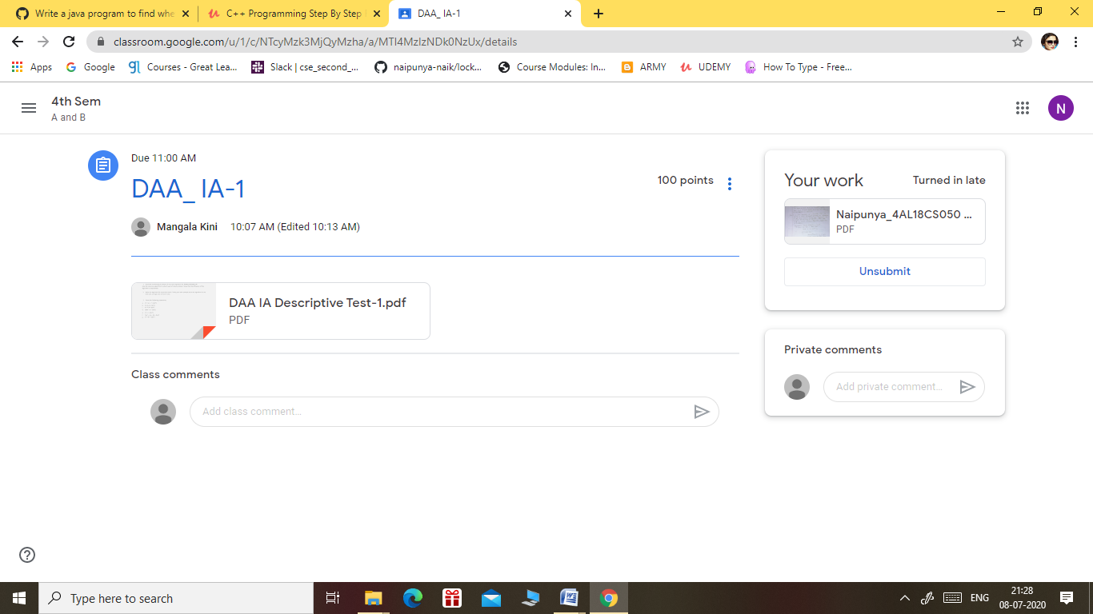

Certification Course Details: (Attach the snapshot and briefly write the report for the same).

CERTIFICATION COURSE NAME:- **C++ PROGRAMMING STEP BY STEP FROM BEGINNER TO ULTIMATE LEVEL**

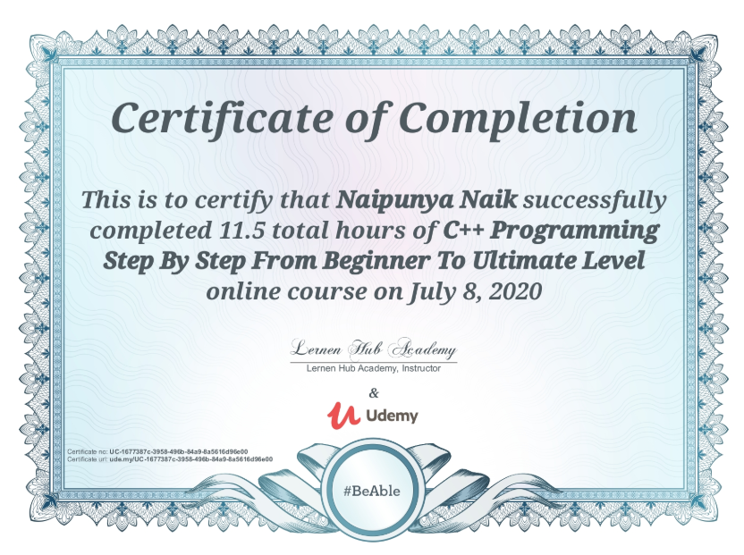

TOPICS COVERED TODAY ON 08 JUNE 2020:-

**Section 12: Hands on Object  
oriented Programming in C++**

**Section 13: Hands on Inheritance In  
C++**

**Section 14: Hands On Advance  
object Oriented Programming**

**Section 15: Hands on File Handling  
in C++**

**Section 16: Hands on the Data  
Structure of C++**

Coding Challenges Details: (Attach the snapshot and briefly write the report for the same).

PROBLEM STATEMENT:-

[Write a java program to find whether the given strings are anagram](https://github.com/orgs/alvas-education-foundation/teams/2nd-year/discussions/147)

Top of Form

Bottom of Form

|  |
| --- |
| Given two strings a and b consisting of lowercase characters. The task is to check whether two given strings are anagram of each other or not. An anagram of a string is another string that contains same characters, only the order of characters can be different. For example, “act” and “tac” are anagram of each other.  **Example:** Input: alvasinsitute aalvsiittnsue allergy allergic  **Output:** YES NO  Explanation: Testcase 1: Both the string have same characters with same frequency. So, both are anagrams. Testcase 2: Characters in both the strings are not same, so they are not anagrams. |

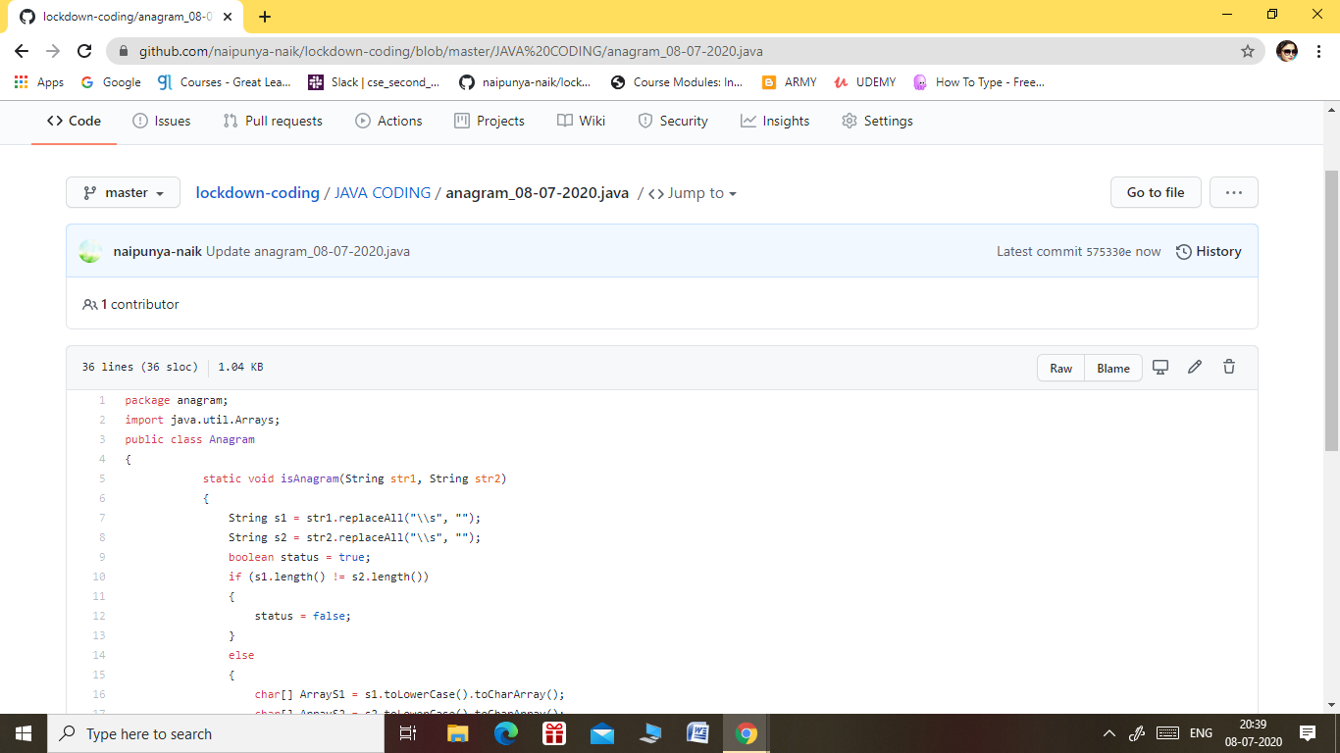

GITHUB REPOSITORY LINK:-

<https://github.com/naipunya-naik/lockdown-coding/blob/master/JAVA%20CODING/anagram_08-07-2020.java>